****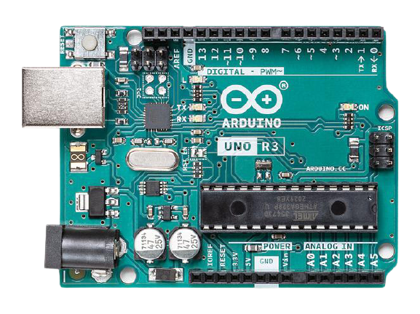

**Home Automation (Using Arduino Board) Working on SDG Goal 4& 11**

**Imran Khan Kerio**

**Team Members**

**Muhammad Azhar CSC-19F-069**

**Muhammad Fasih CSC-19F-089**

**Mehar Khan Niazi CSC-19F-050**

# **Home Automation**

(Using Arduino Board)Working on Sustainable Development Goal 4 & 11

## **Objective**

Technology is rapidly evolving with the passage of time. People and daily life routines rely heavily on the internet. While the cost of living continues to rise, there is a rising emphasis on using technology to reduce those costs. With this in mind, the Smart Home project enables the user to construct and manage a home that is smart enough to conserve energy while also delivering more automated applications. A smart house will make use of its environment and provide smooth management whether the user is there or not.  With this benefit, we can be confident that our home is working optimally in terms of energy efficiency. The world's current challenge is to create smart homes and efficient energy systems (SDG goal 4 & 11)

**Home is where the comfort is. The real comfort lies in living smart & simple**

## **Working**

* The user has total control over all parts of house that can be controlled remotely.
* The automation system will be able to be operated from any location on the planet.
* The System will also detect power management.

## **Scope**

IoT will add 15 trillion dollars to the global economy over the next 20 years

## **Tools & Language**

* Arduino UNO Board
* Wifi Module Chip
* 5V 4-Channels Relay Module
* ohm resistor
* Jumper wires
* USB Cable
* 12V adaptor

Arduino IDE 1.8.16 & Programing Language is C++

## **Operating System Involvement**

The operating system involvement in this project is between the controlling device, Arduino board which we are using is a microcontroller which is a firmware no OS but works like RTOS that helps us rapidly switch between various running parts of our code. Consider it similar to having many loop() routines in an Arduino project that all run at the same time. The OS is also involved in transferring commands from the controller device to the receiver.